REACH OUT TRUST
Annual Report July 2007 to June 2008
Our Earth – Our Land” something within us loves the Land
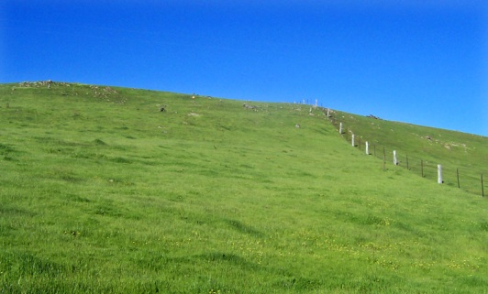 | India is striving to tide over the world wide economic recession, high inflation & rising fuel prices. The problems are many and multiple disasters too. The latest being the multiple bomb blasts in Jaipur. Our country continues to get dragged down by malnutrition, illiteracy, corruption and political apathy. But the young generation is vibrant with hope for the future.
The activities of Reach Out Trust focus on the Warli Tribal people of Talasari West 150 km. north of Mumbai. Our efforts have been mainly in the fields of Education, Health, Empowerment of Women & Youth and tackling Environment and Sanitation issues, here in the northern area of Thane District, Maharashtra .
Imagine a world without butterflies, birds, songs or Children
 | EDUCATION  Our efforts have concentrated on the Pushpavasti School, Vocational Training for youth and Literacy for Women.

The Pushpavasti School last year had 2 additional teachers, Subhash and Urmilla, Urmilla has brought the woman’s touch to the school. She is very lively & enthusiastic. The children have benefited from her qualification in physical training and teaching. The children have delighted everyone with the nimble performance of various drills and dances under her guidance. |  |  | As in the previous years the children have taken away prizes in sports, and special credit for this goes to Santosh, the main strength of the school. Anil took a break this year to do his B’Ed which he has successfully obtained a second class; Anil will be our first qualified Secondary School Teacher. He has worked hard for this, and we are all proud of him, and especially Drs Barbara & Wolfgang Sietz & Michael Langholf who have supported him together with the school activities.
We began the school term by saying farewell to Dr. Christa Merkes Frei who has left for her new home in Australia. Christa has been our pillar of support. We will miss her especially the children whom she loved. We will continue to promote Warli Art and Music to the children. These were Christa’s special interests. |  | The school celebrated an annual prize distribution day in April. Prizes were given for academic and cultural activities The children do well in school performance All the children of the fourth class get admission into the semi private government schools.
Technical Training for Youth
Tailoring is still being favored by the youth. Last year 3 batches completed training, 2 in Dolarpada and one in Dhangadpada. A total of 38 youth completed the tailoring course and were certified . Most of them get jobs (50-60%) in the industrial belt and the rest are self employed. The present 2 batches that started in May have a majority of girls for the first time. |  | All the staff made great efforts to persuade girls to enroll. The girls have a preference to work for small scale industries on daily wages. We managed to convince some of them to take up tailoring, with a promise of helping them to market some of their work. The tailoring teacher is a tribal youth who has trained through our program
Welding courses under the guidance of Sunil Correa have also been conducted in 2 batches of 8 to 10 students.
 | We also had short courses for youth in phenyl making and recently sent 10 boys to the Gokhale Institute in Kosbad to learn the technique of grafting of plants. The youth enjoyed this course & hopefully will practice this in the coming monsoon season
HEALTH
See the Gentle hills, brightly lit at dark and respond with delight”
 | Health through health promotion activities is our main emphasis, Medical care , especially for women &. children, health education, sanitation also have been our priorities
Jyoti Gavde continues to visit villages giving health education and primary care. Besides under five children, she has also this year given attention to pregnant women and their problems. School teachers have also provided medical care to the students of Pushpavasti school. Children were given de-worming medicines, iron and multi vitamin tablets. Common problems of respiratory and skin infection were taken care of. Dr. Tragler sees patients on her visits Five of the community leaders that we trained for community development and health have been appointed as health workers in the Government Primary Health care program. | This year we provided additional nutrition for the children of the Pushpavasti school both in the breakfast and lunch supplementation. Fresh fruits & vegetables from our farm like chikoos, papayas, bananas, mangoes, drumsticks and coconuts are seasonally supplied to the children. For the first time in April 2008, the weight of most of the children had improved. Under weight children were reduced from 40% to16%.

WOMEN EMPOWERMENT
“Get down to Earth and humble Ourselves to Empower”

 | Women traditionally work both in the house and on the land. Warli people worship nature especially in tree & hill formations. We have concentrated on literacy and income generating activities through the 40 women self help groups (SHG’s). These are big assets in strengthening women’s role in a changing society. Manos Unidas of Spain assists us in this program of empowering women through community groups, literacy, health and income generation.
Literacy
It was difficult to sustain the literacy program as women were engaged in agricultural work for 4-5 months and then busy with daily labor work in the various Government of village improvement programs. We have trained 10-15 women from the community to help the staff in literacy and awareness programs. They organize two weekly sessions for Literacy and Awareness. | Two assessments were done of the Literacy & awareness programs that were carried out. Reading writing, health awareness habits were all taken into account. Sr. Marie Noronha & Mrs. Effie Acharya visited twice, to train the teachers and to assess the progress of the women. The assessment showed that 135 of the 400 women (33.75%) had mastered literacy skills of reading writing together with good knowledge on environment (60-70% score) & health. Another 50% (200) had some literacy skills and knowledge (40-50 % score).
Women are very interested in earning money, but literacy and awareness programs are more difficult for them to absorb. The younger women acquire literacy skills better. The older women prefer messages through pictures. Environment and health and social context messages were given to the women. Most of the women grasped these messages. | The women all came together to celebrate Women’s Day on March 8th. They put up a colorful performance of dances and songs. Prizes were given to women and children and there was a community meal later. This year for the first time women from other SHG”s, came to the Pushpavasti school for the common celebration.
SHG’s committee members came to the stage and spoke about the activities of their group. In Dhangadpada members of 2 SHG’s, Shetkari and Ashwini, had together opened small shops. |  | In the Ananti SHG the women together helped each other in preparing the lands for agriculture. Four SHGs have taken up the Government nutrition program.

Subsidies, Loans and Savings
Government subsidy was given to SHG’s for poultry, building construction in Dolarpada. Smaller subsidies of Rupees five to ten thousand were to given to seven SHGs. They were used for constructing bore wells, buying chicken and goats and starting small businesses. | Internal loans were also given to 75 women through the SHGs, mostly for medical expenses, education, house construction and farming. Women contribute Rupees 50 to 100 every month to savings They get loans & subsidies from the government only after saving for six months.
INCOME GENERATION
Not just the look of the clay but the feel of it. To sit on stony banks & work in the fields
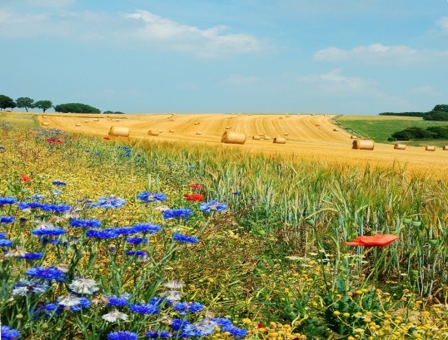 | Since June 2007, we have also been co-coordinating with Ashankur – the objective being to train women to develop skills to earn at least Rs.2,000/- per month. The staff were first given a training program at their center in Ahmednagar under the able guidance of Sr. Daphne. They together with the Trustees put up a project of training women and youth for increasing their earning capacity through tailoring, welding, farming and small enterprises. Thirty women from the various SHG’s were invited to Ahmednagar to visit various projects of Ashankur and the Bosco Center. There was also a market fair and the women had the experience of selling snacks and phenyl that they had made.
In March about 100 women from SHGs were given training at the Kosbad Ghokle Institute. Farming and Poultry as income generating scheme were the topics of training. The exposure trip and the training led to the women & SHG groups to go in for Poultry in a big way. Three thousand one month chickens were ordered by the women from the Bosco center. |  | We are fortunate to have Mahesh Patil trained in the vetenary field on our staff, who is helping the women in their poultry project. The chickens are now 4 months old. They have been vaccinated. Most of the women are hoping to generate income from the eggs. A few have already started selling the cocks. There was however mortality- a total of 10% - mostly in groups that had not taken proper care of the young chicken. This prompted some groups to sell, the chicken, leaving some for egg laying.
Piggery, rice mills, small shops, cooking meals for the children’s nurseries are some schemes taken up by the SHGs. Five SHGs have had some problems and are not contributing to the monthly savings. The staff is trying to sort out their problems.

ENVIORNMENT
Or to plunge our hands into the deep soil
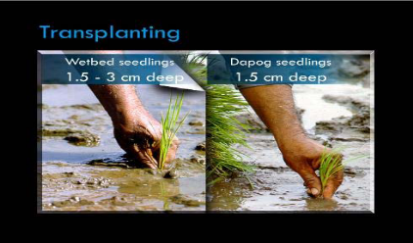 | The Warli’s survive on their agriculture, mainly rice. Most of them have 2-4 acres of land. They only grow rice which is the staple diet. The 2nd crop is not possible, due to lack of water. In the monsoon months, rice is the ideal crop. Some also grow vegetables. After the rice is harvested Goats & Cows are allowed to graze openly in the fields. So even if some manage a second crop the animals become a menace.
In Girgaum 2 SHG members have put bore wells, and fenced some of the land. They are successful in vegetable produce or horticulture. In the last year 500 saplings of fruit trees like cashew, custard apples and mangoes were given to the women and parents. School children in the Pushpavasti school have a vegetable & fruit garden. Pumpkins, brinjals, bananas, papayas are some of their produce. They use the water from a bore well which runs with the help of a solar pump. This year we are making a stronger fence for the school compound. A separate kitchen is also being built at a distance from the school, for a cleaner environment for the children. Government has sanctioned bore wells in 4-5 villages. In Narayanthane the youth are building a fish pond.

In Dhangadpada the construction of the mud dam has again been postponed as the village finally got organized too late with the monsoon approaching. |  | The staff were kept busy organizing / completing the construction of toilets. All the materials were given to the people and instruction how to build toilets. . The majority of the families are using the toilets
The local panchayat also started toilet construction and reimbursed us for fifteen toilets we had built. We hope to construct at least 15 more toilets after the monsoon Majority of villagers now have toilets of their own, but some need completion.
OFFICE AND TRUST LANDS
“Are we tourist here on this land or Residents?”
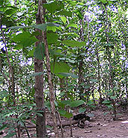  We have all put considerable efforts to enrich the Trust land, hoping for sustainability in the future. We have planted 300 fast growing teak trees and we plan to increase this by another 600 trees this monsoon. | These teak trees are to yield wood in 10 years. Our mango crops are good and so are the chikoos in spite of water problems. We have concentrated on being self sufficient in water. Last year we dug a well. This year our efforts are towards a solar pump and irrigation system. Adolf has taking a keen interest in this. We will have water pumped into our office tank from our well and also catering to most of our water needs. This year hopefully if we have problems with electricity, we can be self sufficient with solar power for irrigation. The assistance of the German Consulate gave us the courage to get our own well.
This year for 4 months, when Adolf & Ancilla Tragler were in the US, we had the internet to come to our rescue. Lily Nazareth was kept busy emailing all the news and progress to us which helped in the decision making and functioning of the project .

FUTURE PLANS
“Who owns the land? May be nobody does, May be we all do”
Some projects that are planned for the next year
- Drip irrigation for the Trust land as a model for other villagers  - Formation of local Trust for the School, who will eventually manage the school  - Sustain present SHG’s & establish more in the nearby villages  - Continue Education, Health & Income Generation activities for 15 villages and hamlets in Talasari, West | - Improve marketing skills of villagers for income generation  - Build more toilets & distribute trees to villagers, start tree nurseries  - Finally complete the earthen dam at Dhangadpada.  - Strengthen our vocational skills & start computer training for staff and youth.
IN GRATITUDE
We wish to thank all our well wishers donors and friends for their contributions to our project. We send bouquets of appreciation to our friends, in Austria, Germany, U.S.A and now Australia too. A special mention of thanks to the S.N.Iyer Q.C&.Dr Irene Iyer Charity Trust, Mumbai, Lotus Trust Germany, Manos Unidas, Spain, German Consulate, Helfende Hand Austria, especially Hannelore Huethmayr, Sophia Polytechnic Mumbai, Ashankur Ahmednagar and Vikar General, Muenster for their kind assistance.

In conclusion REACH OUT TRUST together with its friends has made Land & Life more precious to the simple Warli tribal people of Talasari West, Thane Dist, Maharashtra, India.
Trustees   | Mr. Joseph Keve, MSW, Chairman. Reach Out Trust
 | Mr. Adolf Tragler, MSW, Secretary Reach Out Trust, Director SRS Bandra Mumbai
 | Sr. Marie Noronha, M.ED, Education Specialist
 | Fr. Andrew Rodrigues, Director Social Action. Vasai
 | Mr. Dayanand Ambolkar, MSW
 | Dr. Mrs. Ancilla Tragler, MD, Coordinator Reach Out Trust, Community Health Consultant Pediatrician Holy Family Hospital Bandra
 | Mrs .Anandini Thakoor,. Social Activits
 | Dr. Christa Merkes Frei –former Language Director, Max Mueller Bhavan, retired
 | Irene Iyer, Social Activist S.N. Iyer Q.C & Dr. I. Iyer Charity Trust

Donations for following will be appreciated

1 | Tailoring Vocational Courses | Rs.50,000.00 | 6 months
2 | School Teacher’s Salary | Rs.36,000.00 | Per year
3 | Income Generation Project(Small Scale) like Poultry | Rs.10,000.00 | Per Unit
4 | Children’s Uniform. | Rs. 500.00 | Per each child
5.  6 | Warli Art Promotion  Toilet Construction | Rs. 500.00  Rs.3,000.00 | For 2 small paintings  per family.

Contact: Co-ordinator
Dr. Ancilla Tragler
Tel: 0091 22 26451334
E-mail: atragler@gmail.com

Bankers:
Foreign Contributions: Indian Overseas Bank
Address: 36TH Road, Radhasoami Apts, TP S III
: Bandra (W), Mumbai – 400050, Maharashtra, India.
Savings Bank A/C No: 12770
Swift Code IOBAINBB128

Local Contribution: AXIS Bank,
Address:Turner Road, Bandra(W), Mumbai-400050, Maharashtra, India
Savings Account No. 028010100069553

Sparkonto  Helfende Hand  BOMBAY-Indian  Account No.20479  BLZ (Bank Code) 34427  RAIFFEISENBANK, A-4643 | Kontact:  Hannelore Huethmayr  Duerndorf 34  4643 Pettenbach, Austria
Aruna, Dolarpada  Post :Girgaum  Talasari Sanjan Road  Dist. Thane – 401 606  Phone No.952521 299016 | 10, Samtadeep Bldg., Gr. Floor,  25th Road, Bandra (W),  Mumbai – 400 050  Maharashtra- India  Tel: C 0091-22-26451334  C/o Fax No.0091-22-26518918  email :reachoutmumbai@gmail.com

